**SOFTWARE ENGINEERING**

**ASSIGNMENT NO 3**

# ALISHA FATIMA

# [BSEE21085]

# SUMSAAM HYDER

# [BSEE21009]

# FAISAL AFZAL

# [BSEE21057]

INSTRUCTOR :DR USMAN Younis

TA:MAM AYESHA AMAN

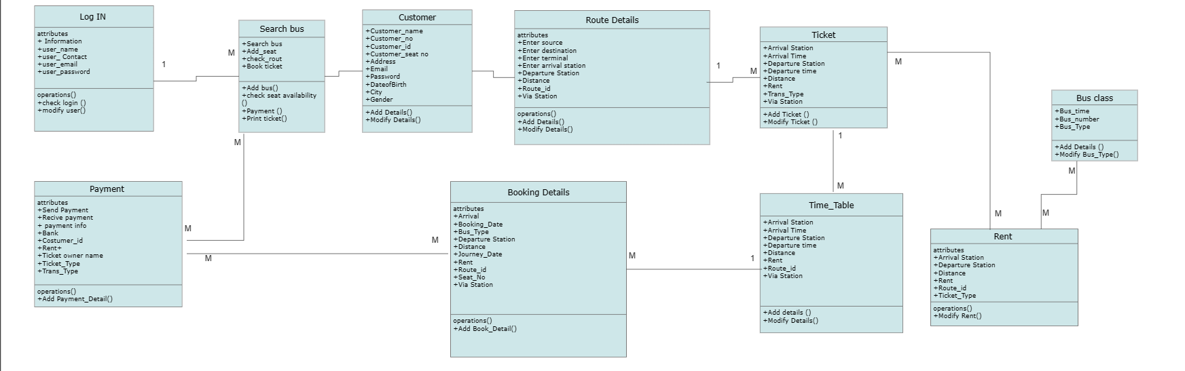

SEQUENCE DIAGRAM

